Java Object-Oriented Programming Experimental Report
NO: Experiment 5 Experiment name：Conditionals and Loops
Student ID | 1607052230 | Name | 邱冠霖 | Class |  | 16软工1班
Location | 实1-314 | Teacher | 唐朝辉 | Time |  | 2018-03-30
1.Experimental purposes and requirements
1.1 Classes and methods
1.2 GUIs: Buttons and Voting with Buttons Textfields
2.Experimental equipment (environment) and requirements
2.1 Eclipse
2.2 Window XP
3.Lab Exercises(Please see Lab Manual)
3.1 Prelab Exercises(Choose to do)
3.2 Computing a Raise
3.3 A Charge Account Statement(Choose to do)
3.4 Activities at Lake LazyDays
3.5 Rock, Paper, Scissors(Choose to do)
3.6 Date Validation(Choose to do)
3.7 Processing Grades(Choose to do)
3.8 Counting and Looping(Choose to do)
3.9 Powers of 2(Choose to do)
3.10 Factorials(Choose to do)
3.11 A Guessing Game
3.12 Baseball Statistics(Choose to do)
3.13 More Guessing(Choose to do)
3.14 Election Day(Choose to do)
3.15 Finding Maximum and Minimum Values(Choose to do)
3.16 Counting Characters(Choose to do)
3.17 Using the Coin Class(Choose to do)
3.18 A Rainbow Program(Choose to do)
3.19 Vote Counter, Revisited
3.20 Modifying EvenOdd
3.21A Pay Check Program(Choose to do)
3.22 Adding Buttons to StyleOptions
4.Experimental results and data processing

5.Analysis and discussion
没有遇到什么问题，源代码都放在github上，欢迎讨论
https://github.com/kong1414/JavaLesson.git
6.Teacher Reviews  Signature：  Date： |  |  |  |  | Score:

Experimental Report List
1 Computing a Raise
1) Source code list

package chapter05;
import java.text.NumberFormat;
import java.util.Scanner;
/**
* @Description:
* @Author: QiuGuanLin
* @Date: 2018/3/30 10:18
*/
public class Salary {
public static void main(String[] args) {
double currentSalary;
// employee's current salary
double raise = 0;
// amount of the raise
double newSalary;
// new salary for the employee
String rating;
// performance rating
Scanner scan = new Scanner(System.in);
System.out.print("Enter the current salary: ");
currentSalary = scan.nextDouble();
System.out.print("Enter the performance rating (Excellent, Good, or Poor): ");
rating = scan.next();
// Compute the raise using if ...
if ("Excellent".equals(rating)) {
raise = currentSalary * 0.06;
} else if ("Good".equals(rating)) {
raise = currentSalary = 0.04;
} else if ("Poor".equals(rating)) {
raise = currentSalary = 0.015;
}
newSalary = currentSalary + raise;
// Print the results
NumberFormat money = NumberFormat.getCurrencyInstance();
System.out.println();
System.out.println("Current Salary: " + money.format(currentSalary));
System.out.println("Amount of your raise: " + money.format(raise));
System.out.println("Your new salary: " + money.format(newSalary));
System.out.println();
}
}

2) Results data processing
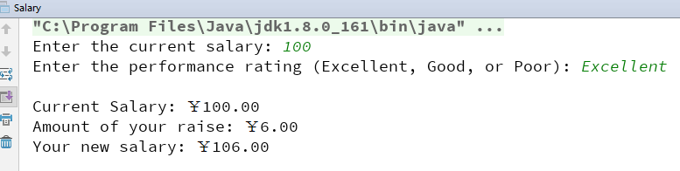

3) Answer questions

4)Error Analysis and Discussion

4 Activities at Lake LazyDays
1) Source code list

package chapter05;
import java.util.Scanner;
/**
* @Description:
* @Author: QiuGuanLin
* @Date: 2018/3/30 10:27
*/
public class LazyDays {
public static void main(String[] args) {
double temp;
Scanner scan = new Scanner(System.in);
System.out.print("Enter the temp: ");
temp = scan.nextDouble();
if (temp > 95 || temp < 20) {
System.out.println("Visit our shops!");
} else if (temp >= 80) {
System.out.println("swimming");
} else if (temp >= 60) {
System.out.println("tennis");
} else if (temp >= 40) {
System.out.println("golf");
} else {
System.out.println("skiing");
}
}
}

2) Results data processing
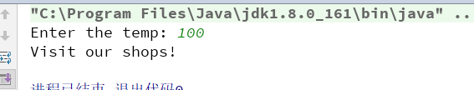
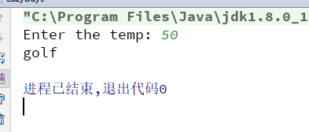
3) Answer questions

4)Error Analysis and Discussion

11 A Guessing Game
1) Source code list
package chapter05;
import java.util.Random;
import java.util.Scanner;
/**
* @Description: Play a game where the user guesses a number from 1 to 10
* @Author: QiuGuanLin
* @Date: 2018/3/30 10:29
*/
public class Guess {
public static void main(String[] args) {
int numToGuess; //Number the user tries to guess
int guess; //The user's guess
int gn = 1;
int high = 0, low = 0;
Scanner scan = new Scanner(System.in);
Random generator = new Random();
//randomly generate the number to guess
numToGuess = generator.nextInt(10) + 1;
//print message asking user to enter a guess
System.out.print("Please enter a guess number between 1 and 10:");
//read in guess
guess = scan.nextInt();
//keep going as long as the guess is wrong
while (numToGuess != guess) {
//print message saying guess is wrong
if (numToGuess < guess) {
high++;
System.out.println("The guess is wrong ! The guess is too high!"
+ "Guess high time is " + high);
} else {
low++;
System.out.println("The guess is wrong ! The guess is too low!"
+ "Guess low time is " + low);
}
//get another guess from the user
System.out.print("Please enter a guess number between 1 and 10 again:");
guess = scan.nextInt();
gn++;
}
//print message saying guess is right
System.out.println("The guess is right ! Guess number is " + gn);
}
}

2) Results data processing
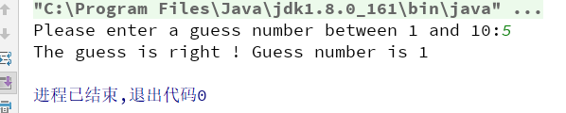
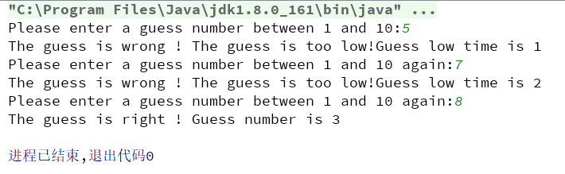
3) Answer questions

4)Error Analysis and Discussion

17 Using the Coin Class
1) Source code list

package chapter05;
/**
* @Description:
* @Author: QiuGuanLin
* @Date: 2018/3/30 10:39
*/
public class Runs {
public static void main(String[] args) {
final int FLIPS = 100;
// number of coin flips
int currentRun = 0;
// length of the current run of HEADS
int maxRun = 0;
// length of the maximum run so far
// Create a coin object
Coin myCoin = new Coin();
// Flip the coin FLIPS times
for (int i = 0; i < FLIPS; i++) {
// Flip the coin & print the result
myCoin.flip();
// Update the run information
if (myCoin.isHeads()) {
currentRun++;
} else {
if (currentRun > maxRun) {
maxRun = currentRun;
}
currentRun = 0;
}
}
// Print the results
System.out.println("连续heads面朝上的最大次数为 " + maxRun + " 次.");
}
}

package chapter05;
/**
* @Description:
* @Author: QiuGuanLin
* @Date: 2018/3/30 10:39
*/
public class Coin {
public final int HEADS = 0;
public final int TAILS = 1;
private int face;
// ---------------------------------------------
// Sets up the coin by flipping it initially.
// ---------------------------------------------
public Coin() {
flip();
}
// -----------------------------------------------
// Flips the coin by randomly choosing a face.
// -----------------------------------------------
public void flip() {
face = (int) (Math.random() * 2);
}
// ---------------------------------------------------------
// Returns true if the current face of the coin is heads.
// ---------------------------------------------------------
public boolean isHeads() {
return (face == HEADS);
}
// ----------------------------------------------------
// Returns the current face of the coin as a string.
// ----------------------------------------------------
@Override
public String toString() {
String faceName;
if (face == HEADS) {
faceName = "Heads";
} else {
faceName = "Tails";
}
return faceName;
}
}

2) Results data processing
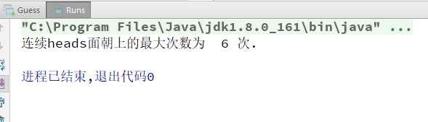
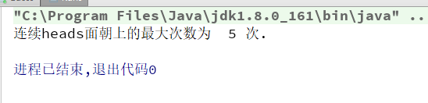
3) Answer questions

4)Error Analysis and Discussion

19 Vote Counter, Revisited
1) Source code list

package chapter05;
import javax.swing.*;
/**
* @Description:
* @Author: QiuGuanLin
* @Date: 2018/3/30 10:50
*/
public class VoteCounter {
//----------------------------------------------
// Creates the main program frame.
//----------------------------------------------
public static void main(String[] args) {
JFrame frame = new JFrame("Vote Counter");
frame.setDefaultCloseOperation(JFrame.EXIT_ON_CLOSE);
frame.getContentPane().add(new VoteCounterPanel());
frame.pack();
frame.setVisible(true);
}
}
package chapter05;
import javax.swing.*;
import java.awt.*;
import java.awt.event.ActionEvent;
import java.awt.event.ActionListener;
/**
* @Description:
* @Author: QiuGuanLin
* @Date: 2018/3/30 10:50
*/
public class VoteCounterPanel extends JPanel {
private int votesForJoe;
private JButton joe;
private JLabel labelJoe;
private int votesForSam;
private JButton sam;
private JLabel labelSam;
private JButton js;
private JLabel labelJs;
//----------------------------------------------
// Constructor: Sets up the GUI.
//----------------------------------------------
public VoteCounterPanel() {
votesForJoe = 0;
votesForSam = 0;
joe = new JButton("Vote for Joe");
sam = new JButton("Vote for Sam");
joe.addActionListener(new VoteButtonListener());
sam.addActionListener(new VoteButtonListener());
labelJoe = new JLabel("Votes for Joe: " + votesForJoe);
labelSam = new JLabel("Votes for Sam: " + votesForSam);
add(joe);
add(labelJoe);
add(sam);
add(labelSam);
js = new JButton("统 计 结 果 :");
labelJs = new JLabel(" ");
add(js);
add(labelJs);
js.addActionListener(new VoteButtonListener());
setPreferredSize(new Dimension(300, 120));
setBackground(Color.orange);
}
//***************************************************
// Represents a listener for button push (action) events
//***************************************************
private class VoteButtonListener implements ActionListener {
//----------------------------------------------
// Updates the appropriate vote counter when a
// button is pushed for one of the candidates.
//----------------------------------------------
@Override
public void actionPerformed(ActionEvent event) {
if (event.getSource() == joe) {
votesForJoe++;
labelJoe.setText("Votes for Joe: " + votesForJoe);
} else if (event.getSource() == sam) {
votesForSam++;
labelSam.setText("Votes for Sam: " + votesForSam);
} else if (event.getSource() == js) {
if (votesForJoe > votesForSam) {
labelJs.setText("Joe win !");
} else if (votesForJoe < votesForSam) {
labelJs.setText("Sam win !");
} else {
labelJs.setText("Tie !");
}
}
}
}
}

2) Results data processing
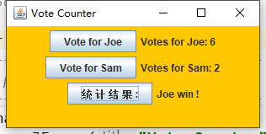

3) Answer questions

4)Error Analysis and Discussion

20 Modifying EvenOdd
1) Source code list
package chapter05;
import javax.swing.*;
/**
* @Description: 计算并显示所输入整数的平方根
* @Author: QiuGuanLin
* @Date: 2018/3/30 10:58
*/
public class SquareRoots {
public static void main(String[] args) {
String numStr, result;
int num, again;
do {
numStr = JOptionPane.showInputDialog("计算并显示所输入整数的平方根\nEnter an integer: ");
num = Integer.parseInt(numStr);
result = "That number's SquareRoots is " + Math.sqrt(num);
JOptionPane.showMessageDialog(null, result);
again = JOptionPane.showConfirmDialog(null, "Do Another?");
}
while (again == JOptionPane.YES_OPTION);
}
}

2) Results data processing
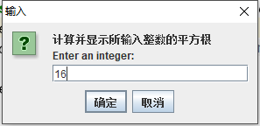
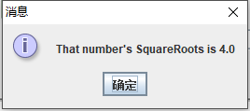
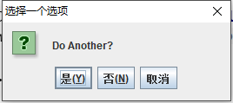
3) Answer questions

4)Error Analysis and Discussion

22 Adding Buttons to StyleOptions
1) Source code list

package chapter05;
import javax.swing.*;
/**
* @Description:
* @Author: QiuGuanLin
* @Date: 2018/3/30 11:04
*/
public class StyleOptions {
//-----------------------------------------------------------------
// Creates and presents the program frame.
//-----------------------------------------------------------------
public static void main(String[] args) {
JFrame frame = new JFrame("Style Options");
frame.setDefaultCloseOperation(JFrame.EXIT_ON_CLOSE);
StyleOptionsPanel panel = new StyleOptionsPanel();
frame.getContentPane().add(panel);
frame.pack();
frame.setVisible(true);
}
}

package chapter05;
import javax.swing.*;
import java.awt.*;
import java.awt.event.ItemEvent;
import java.awt.event.ItemListener;
/**
* @Description:
* @Author: QiuGuanLin
* @Date: 2018/3/30 11:04
*/
public class StyleOptionsPanel extends JPanel {
private int fontSize = 36;
private int style = Font.PLAIN;
private JLabel saying;
private JCheckBox bold, italic;
//-----------------------------------------------------------------
// Sets up a panel with a label and some check boxes that
// control the style of the label's font.
//-----------------------------------------------------------------
public StyleOptionsPanel() {
saying = new JLabel("Say it with style!");
saying.setFont(new Font("Helvetica", style, fontSize));
bold = new JCheckBox("Bold");
bold.setBackground(Color.cyan);
italic = new JCheckBox("Italic");
italic.setBackground(Color.cyan);
StyleListener listener = new StyleListener();
bold.addItemListener(listener);
italic.addItemListener(listener);
add(saying);
add(bold);
add(italic);
setBackground(Color.cyan);
setPreferredSize(new Dimension(300, 100));
}
//*****************************************************************
// Represents the listener for both check boxes.
//*****************************************************************
private class StyleListener implements ItemListener {
//--------------------------------------------------------------
// Updates the style of the label font style.
//--------------------------------------------------------------
@Override
public void itemStateChanged(ItemEvent event) {
style = Font.PLAIN;
if (bold.isSelected()) {
style = Font.BOLD;
}
if (italic.isSelected()) {
style += Font.ITALIC;
}
saying.setFont(new Font("Helvetica", style, fontSize));
}
}
}

2) Results data processing
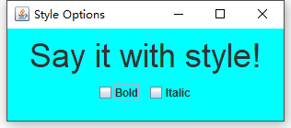
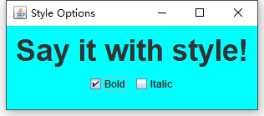
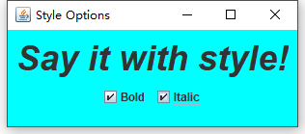
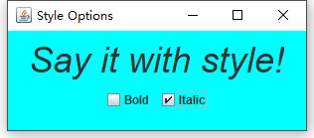
3) Answer questions

4)Error Analysis and Discussion

1 Computing a Raise
1) Source code list

2) Results data processing

3) Answer questions

4)Error Analysis and Discussion

